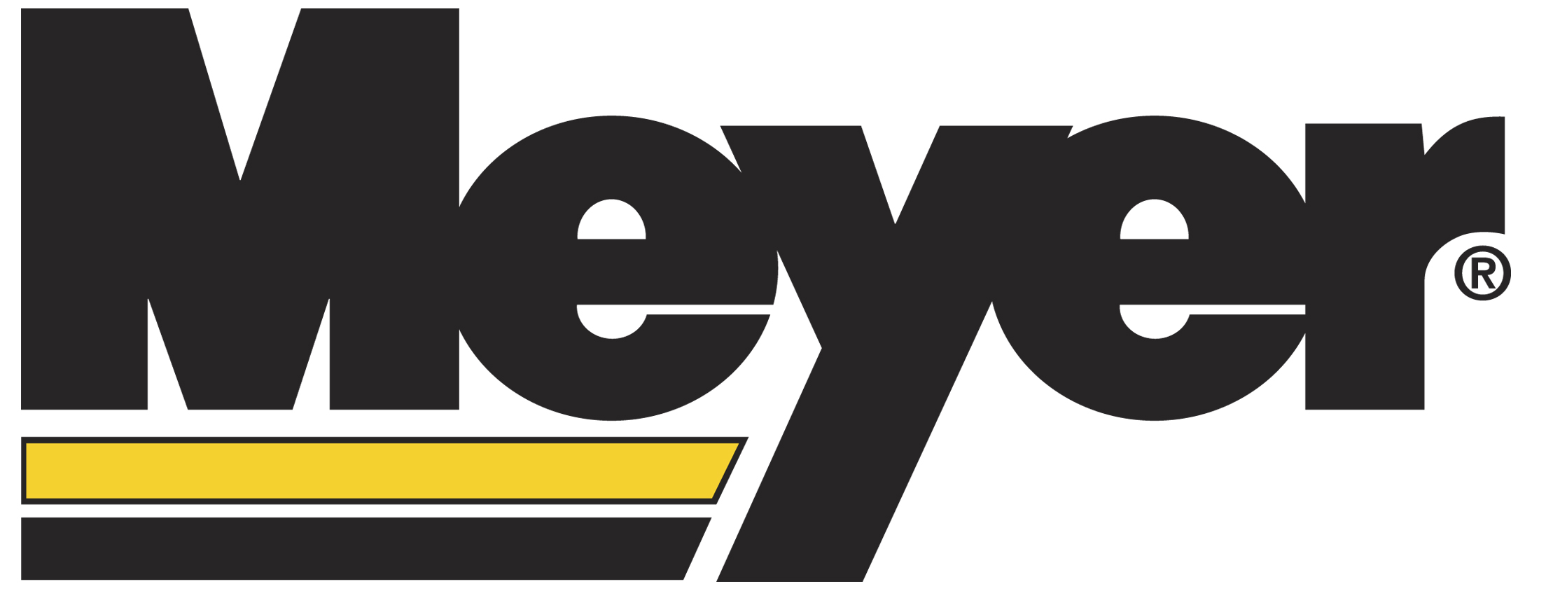

Turn Your Skid Steer Into An All-Season Performer

CLEVELAND (November 2010) -- Meyer Products offers a Lot Pro snowplow that can easily be added to a wide variety of skid steers making them ideal for plowing snow or ice in confined areas, driveways or commercial applications. For mounting to skid steers, Meyer’s exclusive floating mount allows the Lot Pro moldboard to follow the contour of the surface to minimize the damage to the roadway or driveway. The aggressive moldboard attack angle and superior snow rolling action provide excellent snow removal with improved clearing performance which is not currently available on conventional skid steer plows. Other plow manufacturers can only offer a fixed mount system that utilizes the downward pressure of the loader arms to scrape the snow. This increases the potential for surface and equipment damage or hydraulic failures. Optional urethane or rubber cutting edges can be added to any Lot Pro so you can use your skid steer to plow decorative concrete or road surfaces without damage.

By choosing a Meyer power- or manual- angling kit, you get the ability to position the blade left or right, in addition to the up/down movement found on traditional skid steers. Meyer is the only manufacturer that gives you left/right blade positioning for skid steers.

For the ultimate in performance, attach Meyer’s 9-position wings on each end of the Lot Pro moldboard. This allows you to independently position each wing to create a box, scoop or straight blade configuration by pulling just one pin. When using the straight or scoop positions, you get the performance you need for plowing driveways or commercial lots. Adjust the wings to the box position and you have the perfect solution to clear confined areas or stacking snow.

Meyer Products LLC is a leading manufacturer of highly reliable snow and ice control systems. Meyer’s product innovations and industry knowledge have been improving transportation safety and convenience since the day it invented snowplows more than 80 years ago. For more information, contact Meyer Products LLC, 18513 Euclid Avenue, Cleveland, OH 44112; Marge Lang at (216) 486-1313 or lang@meyerproducts.com; www.meyerproducts.com.

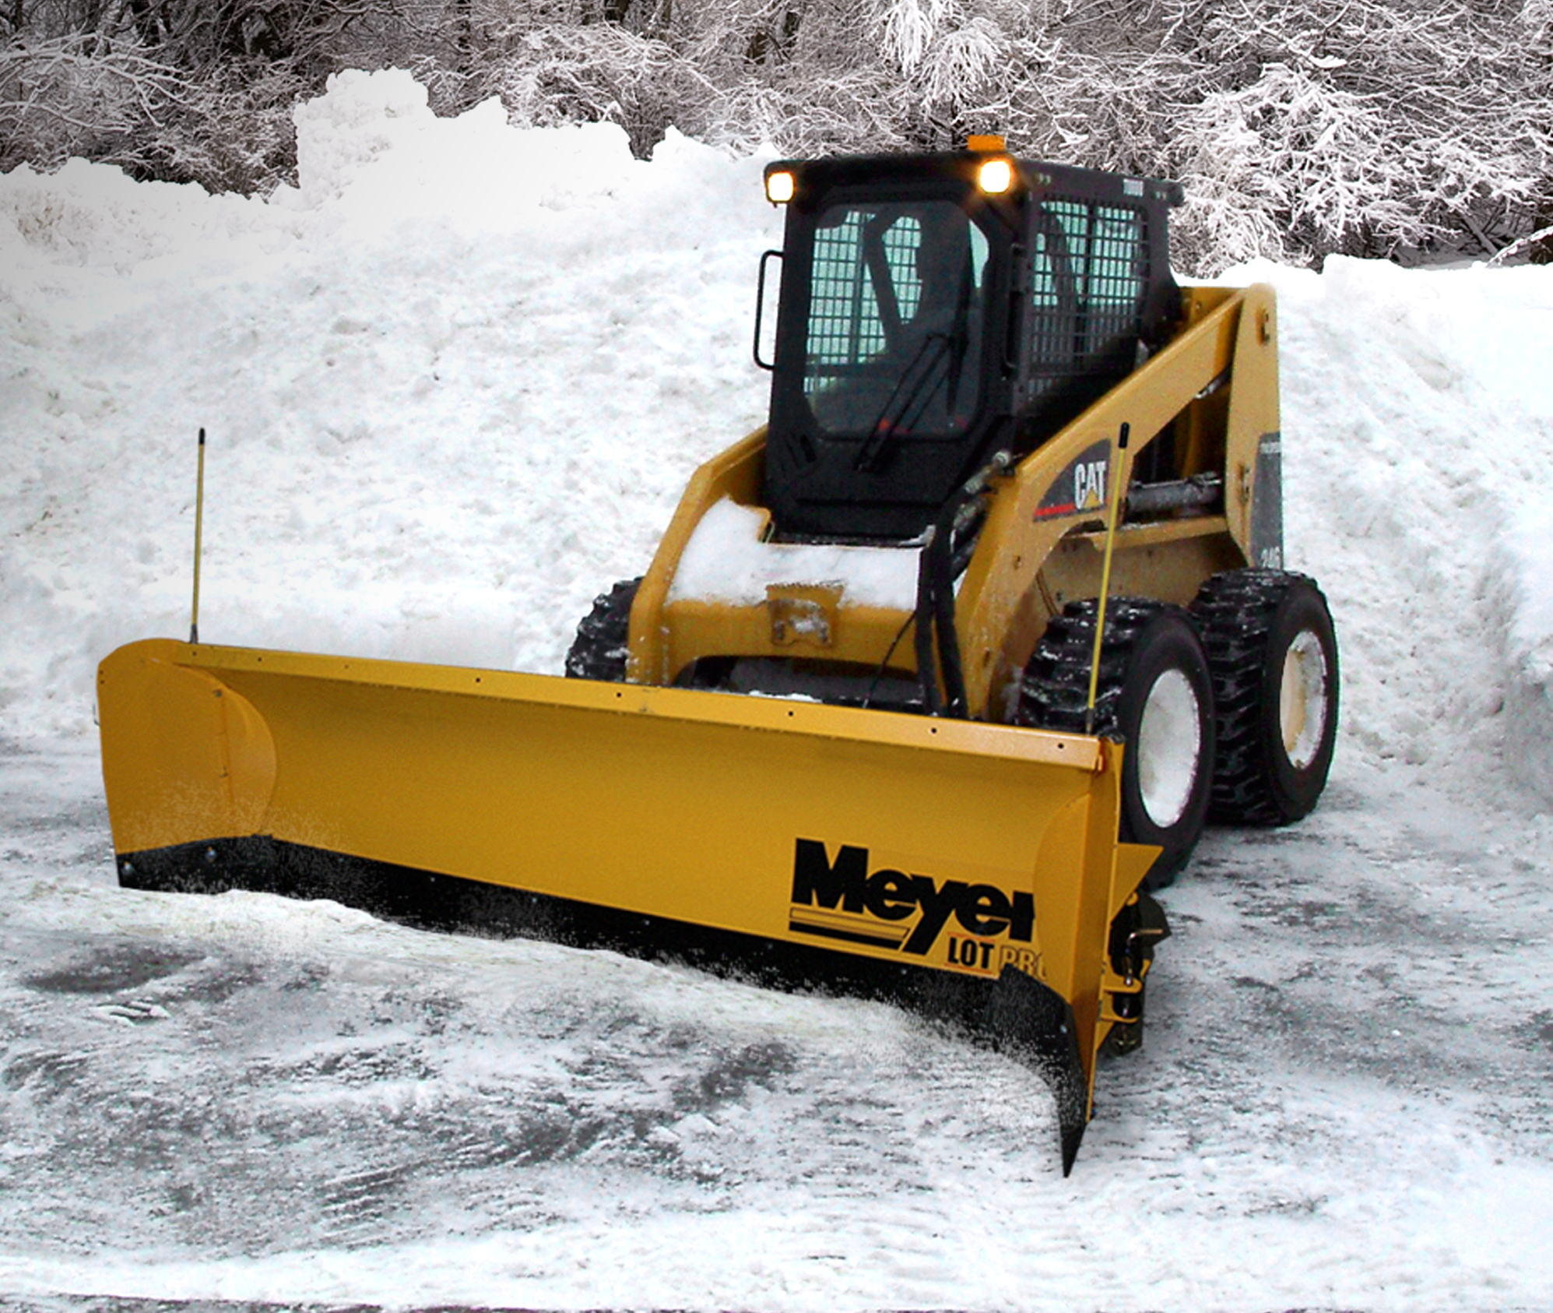
Skid steer shown with Meyer Lot Pro Plow and exclusive 9-position wings.

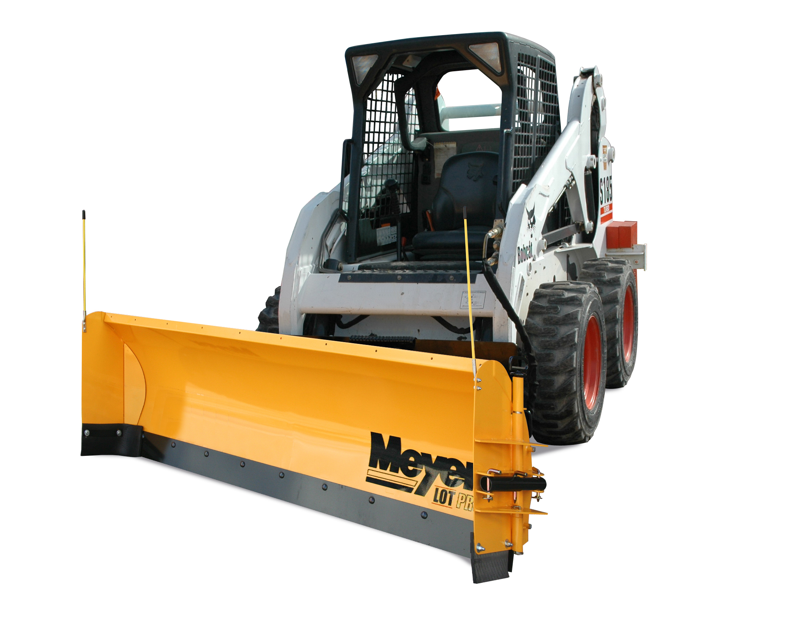
Meyer skid steer plow systems allow you to position the blade left or right, in addition to the up/down blade movement found on traditional skid steer plows.

